Team three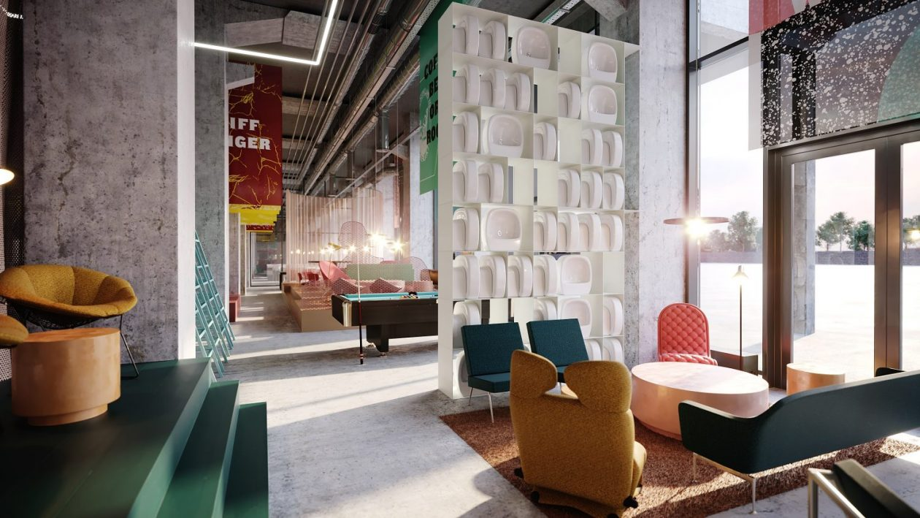

The Ambient Student House

Prepared for: Student Housing Inc.

Prepared by: Alexander Barhoum, Emeric Besson, Damiën Bück, Johnson Domacassé

10 November 2022

Team three

Introduction 3

Current Situation 3

Proposed solution 5

Deliverables 6

Scope 6

Schedule 9

Risk assessment 10

Team Structure 10

Executive Summary 10

retrospectives 10

Team three

# Introduction

Background

Student Housing Inc. is developing a new concept of a student house that provides ambient and smart facilities for a pleasant stay and an excellent study environment.

The Ambient Student House aims to provide spaces where students can live, study and socialize with

other students. What we discovered along the way, is that a supportive atmosphere really inspires

those who encounter it. A smart ambience provides a place with optimal conditions for students to

focus on their studies.

In principle, each room is a separate ambient environment that can provide a specific atmosphere for

the guests. The different rooms have specific ambience and appliances, such as kitchens, flexible co-

working spaces, chill-out lounges, libraries, meeting rooms, etc.

Mission

Our team has been assigned to work on the smart ambient system for the project. We have been tasked to design a smart system that can control and monitor multiple environment parameters like: lighting and security to help improve the overall experience of the students residing in the student house. In addition to that, the system will handle other aspects of the students’ stay like: safety and temperature.

# Current Situation

Problem definition

Our team has identified and decided to act on the following problems:

## 1. Lack of automated control for temperature and humidity inside facilities:

The current building has a heating system that needs to be controlled manually by staff. This system requires constant supervision and effort from the staff to control it and maintain in order to ensure waste-less use.

Team three

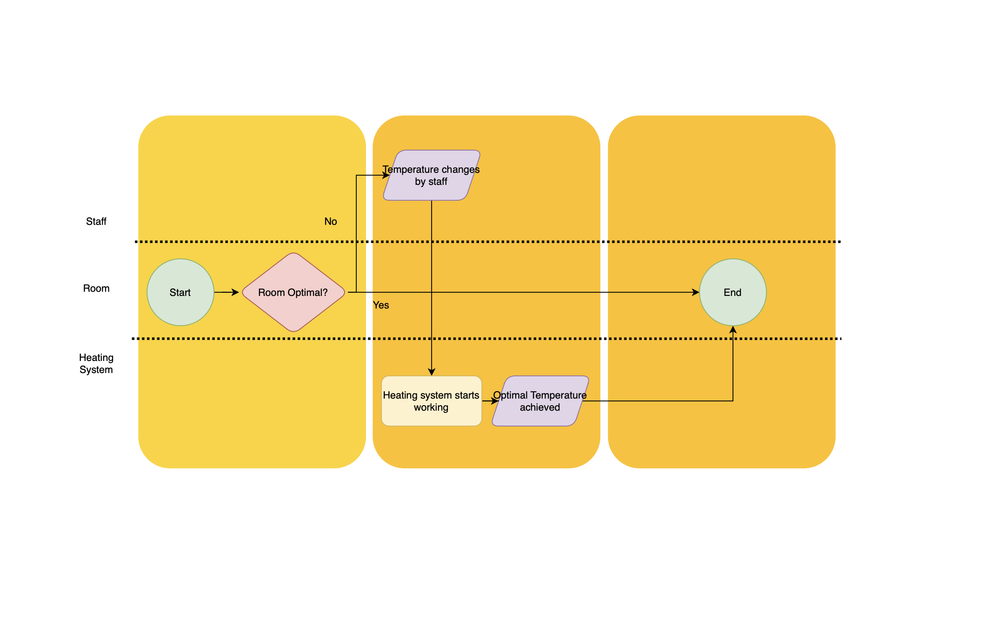

Caption

## 2. Lack of automated control for Lighting inside facilities:

All lights in the facilities at the new student hotel need to be turned off and on manually. That also requires continuous monitoring and control by the staff. An additional feature would be to alternate between a cold and warm ambience for a better work environment.

## 3. (Security concern) Lack of a smart security system for the dorm rooms:

Currently, the security at the student house is provided by security staff who actively ensure that the building is secured. We want to include some sort of id-tag system for more security.

## 4. (Safety concern) Lack of a smart fire alarm system for the building:

The student house building now has a fire alarm system that is not capable of estimating the number of people inside a building to ensure no one is left inside in case of a fire and to facilitate an efficient vacating operation.

# Proposed solution

Team three

## Designing an automated control system for the temperature and humidity inside facilities:

This system will automatically monitor and regulate the temperature and humidity inside all facilities, thereby replacing the human resources requires previously to do these tasks. It will also reduce the thermal and energy waste caused by delay in regulating temperature and humidity.

## 2. Designing an automated control system for lighting inside facilities:

This system will automatically monitor and regulate lighting inside all facilities, thereby replacing the human resources requires previously to do these tasks. Just like the previous the solution, this is expected to reduce the energy waste caused by delay in regulating lighting.

## 3. Designing an automated control system for the dorm rooms doors:

This system will automatically detect break-ins and theft attempts when someone is trying to open the door without authorization first. This system will use RFID-technology to do so.

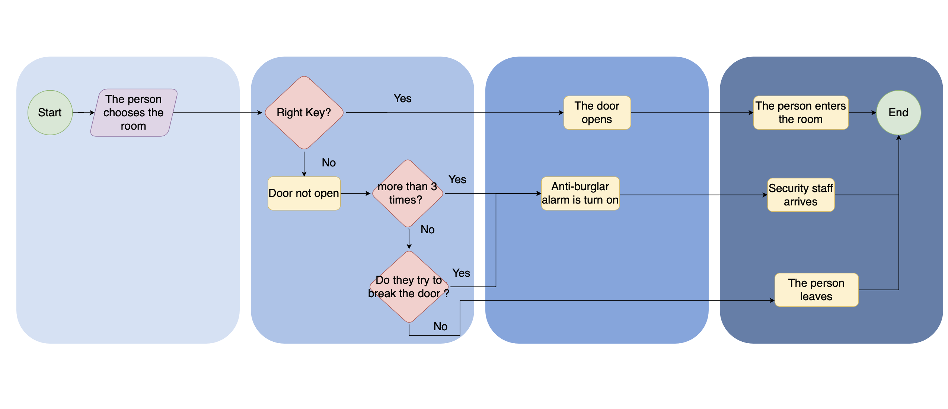

Caption

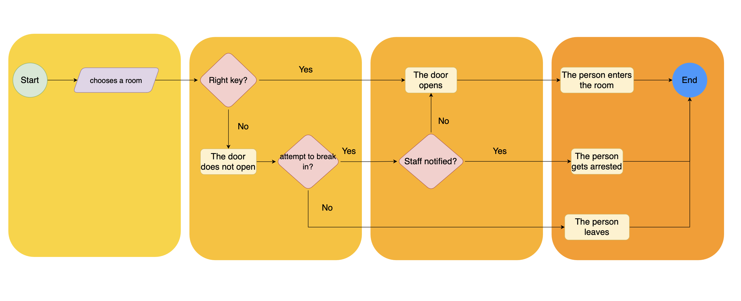

Caption

## 4. Designing a smart fire alarm system:

This system will detect how many people enter the building to ensure a successful vacating process in case of a fire. It will also automatically ensure that an alarm is sound when a fire is detected.

# Deliverables

## Graphical User Interface to control and monitor Temperature, humidity, and lighting.

## 2. Theft detecting system for the dorm rooms.

## 3. Smart fire alarm system.

## 4. Automatic temperature system.

## 5. Functional lighting system for both warm and cold ambience.

# Scope

## Graphical User Interface to control and monitor Temperature and lighting

Automation:

This system will automatically regulate temperature and lighting for all facilities inside the student house.

* Lighting will be modified and optimized to ensure the best experience for students with respect to: the facility’s function, time of the day, student’s preferences.
* Temperature will be controlled to ensure that the all facilities inside will have an indoor temperature within a range of at least 1 degree Celsius of the pre-dedicated temperature setting.

Control:

* Users with no administrative privileges like students can change the lighting under certain circumstances through a graphical user interface. Setting time of day manually in case they prefer to work/relax a different that usual time. Turning the lights on and off.
* The users can also toggle between the smart (automatic system) to the manual system.

Interface:

* the graphical user interface that will be designed for the system will be in the form of an application that can be accessed on monitors which can be fixed on the walls of the facilities.

## 2. Theft detecting system for the dorm rooms

Automation:

This system will automatically detect theft attempts in the students dorms by detecting repeated card denial and lock damage.

Control:

Only users with certain administrative privileges like security staff will have access to the user interface developed for this system

Interface:

the graphical user interface that will be designed for the system will be in the form of an application that can be accessed on monitors which can only be accessed in the security section of the building.

## 3. Smart fire alarm system

Automation:

This system will automatically detect fire incidents and act on them to ensure that all students are safe by providing an estimate of the number of people inside the facilities, setting off an alarm that instructs everyone in inside the facilities to vacate immediately.

Control:

Only users with certain administrative privileges like security staff will have access to the user interface developed for this system.

Users with no administrative privileges can only activate the alarm through a button or manual switches within buildings.

Interface:

the graphical user interface that will be designed for the system will be in the form of an application that can be accessed on monitors which can only be accessed in the security section of the building.

# executive summary.

| WEEK | WEEK 11 | WEEK 12 | WEEK 13 |
| --- | --- | --- | --- |
| MONDAY | C# SOFTWARE | C# SOFTWARE | C# SOFTWARE |
| TUESDAY | PROGRAMMING | PROGRAMMING | PROGRAMMING |
| WEDNESDAY | PROJECT | PROJECT | PROJECT |
| THURSDAY | COMPONENTS | COMPONENTS | COMPONENTS |
| FRIDAY | PROJECT | PROJECT | PROJECT |
| WEEK | WEEK 14 | WEEK 15 | WEEK 16 |
| MONDAY | C# SOFTWARE | C# SOFTWARE | PROJECT |
| TUESDAY | PROGRAMMING | PROGRAMMING | PROJECT |
| WEDNESDAY | PROJECT | PROJECT | PROJECT |
| THURSDAY | COMPONENTS | COMPONENTS | PROJECT |
| FRIDAY | PROJECT | PROJECT | PROJECT |
| WEEK | WEEK 17 | WEEK 18 | WEEK 19 |
| MONDAY | PROJECT | PROJECT | N/A |
| TUESDAY | PROJECT | PROJECT DEADLINE | N/A |
| WEDNESDAY | PROJECT | PRESENTATION | N/A |
| THURSDAY | PROJECT | N/A | N/A |
| FRIDAY | PROJECT | N/A | N/A |
|  |  |  |  |

# Risk assessment

| RISK | DESCRIPTION. | EFFECT ON PROJECT. | (POTENTIAL)  SOLUTION. |
| --- | --- | --- | --- |
| COMMUNICATION. | 1.1 | MEDIUM | 2.1 |
| PRESENCE. | 1.2 | MEDIUM | 2.2 |
| SYSTEM. | 1.3 | HIGH | 2.3 |
| TIME MANAGEMENT. | 1.4 | HIGH | 2.4 |
| DESIGN. | 1.5 | LOW | 2.5 |

Descriptions:

* 1. :

Problem that can occur in the situation where team members fail to communicate optimally. This can range from not having a task done to strong arguments.

* 1. :

Problems that can occur when 1 or more team members are not present to work on the project. This can lead to communication problems and even potential problems making the system.

* 1. :

Problems that can occur when the system is not functional. This can be from poor or different methods of coding. Different parts of code contradicting each other. Integrating both the C++ and the C# code. This is a very big risk because if we don’t have a working system, we essentially don’t have a project.

* 1. :

Problems that can occur when we have poor planning to manage our time better. This can cause that we won’t have our project done on time or stress in the last parts of the project.

* 1. :

Problems that can occur when the design of the entire system looks poor. Think for example cable management or a non-appealing GUI.

Solutions:

2.1 :

A solution would be to use an app to see what tasks there are and which tasks can be done or are done. Another would be to talk in the team chat about your progress of the day. So in other words a scrum meeting.

2.2 :

One solution could be to work from home. For example maybe this person cannot come to school that day because of reasons that aren’t sickness. This person can simply work on one of the many tasks at home and the next time he comes, he has something to show for it.

2.3 :

There can be many problems that can keep us from having a working system. The solution to most of them would be to just try and fix it yourself. If this is unsuccessful, we have many teachers at our disposal for help.

2.4 :

The same situation as 2.1, have a meeting either daily work weekly to see which tasks can be done or are done but this time you could add how long it would take for these tasks. As well as make a better time management plan at the start of the project. This way, you have a more global approach as to when certain tasks should be finished.

2.5 :

If you have enough time this should not be an issue. If you lack creativity you can ask for the opinion of others. If you have difficulty managing your wires, you could try and make your system “cleaner” by using less wires. If this is not possible you can use something to cover the parts that are not needed. These all can make the system look cleaner.

# Team Structure

Lead light system: Damien Buck

Lead alarm system: Emeric Besson

Lead security system: Alexander Barhoum

Lead temperature system: Johnson Domacasse

## 